**ASSIGNMENT – 3**

**SMART FASHION RECOMMENDER APPLICATION**

|  |  |
| --- | --- |
| Project Name | Smart Fashion Recommender Application |
| Team ID | PNT2022TMID07960 |

**Questions:**

1. Create a Bucket in IBM object storage.
2. Upload 5 images to IBM object storage and make it public. Write html code to displaying all the 5 images.
3. Upload a CSS page to the object storage and use the same page in your HTML code.

4.Design a chatbot using IBM Watson assistant for hospital. Ex: User comes with query to know the branches for that hospital in your city. Submit the web URL of that chat bot as a assignment.

5.Create Watson assistant service with 10 steps and use 3 conditions in it. Load that script in HTML page.

**Create a Bucket in IBM object storage.**

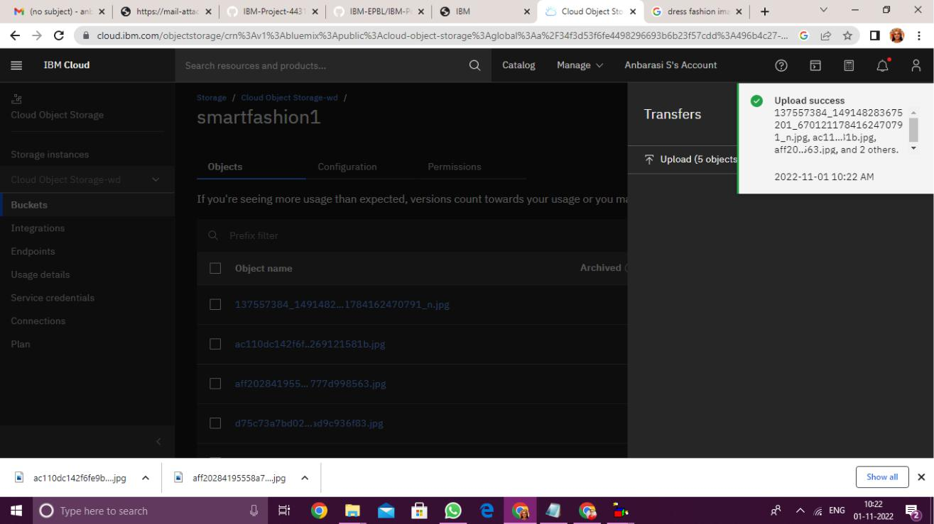

**Upload an 5 images to IBM object storage**

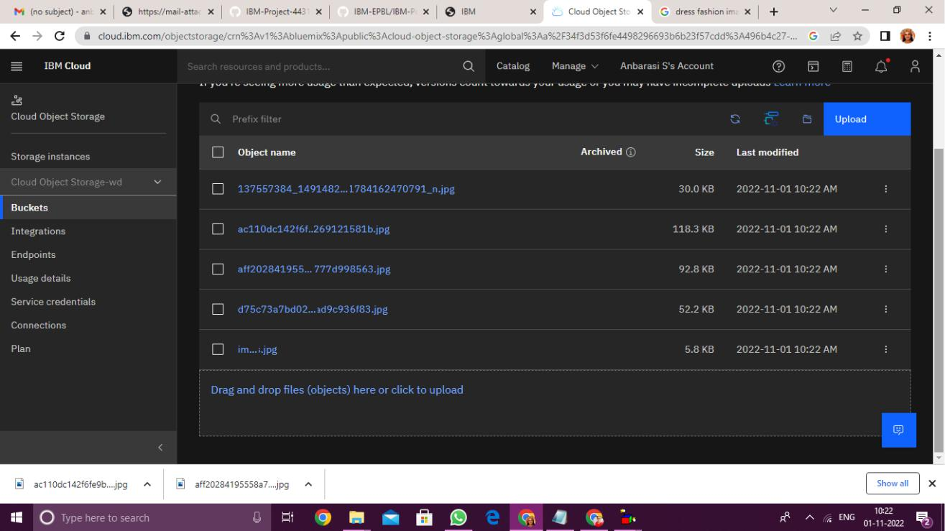

**Make the images to public access:**



**Displaying the images :**

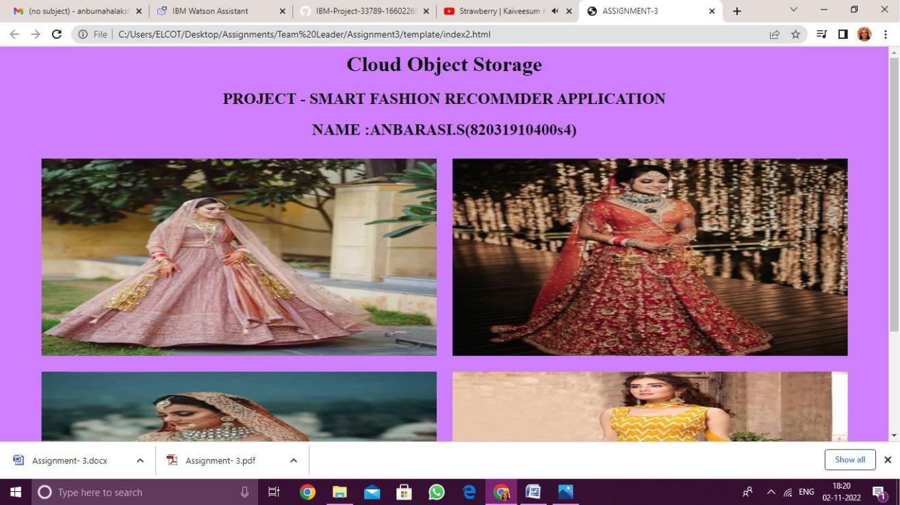

**Create a Chatbot :**

**CHATBOT URL :**

**https://web-**

**chat.global.assistant.watson.appdomain.cloud/preview.html?backgroundImageURL=https%3A%2**

**F%2Fjp-tok.assistant.watson.cloud.ibm.com%2Fpublic%2Fimages%2Fupx-c371dcde-b75b-4b8f-**

**aa33-abd1b615fa7d%3A%3A3c928eb7-b86b-4987-8011-28bd0b23488b&integrationID=238a365b-**

**6981-4baf-b761-3555f7f9f4c9&region=jp-tok&serviceInstanceID=c371dcde-b75b-4b8f-aa33-**

**abd1b615fa7d**

**Create Watson assistant with 10 steps and use 3 conditions in it:**

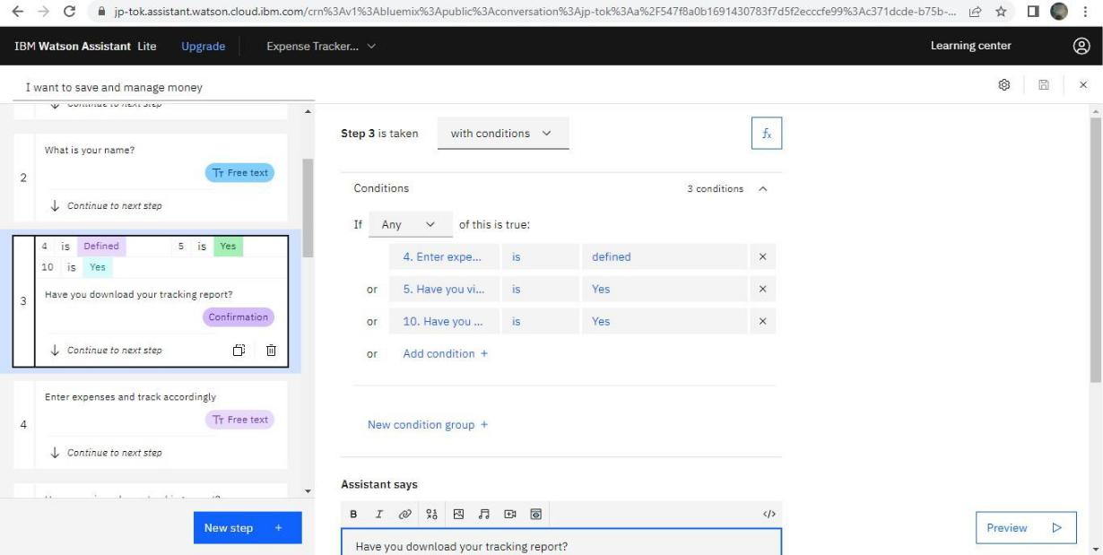

**Load that script in HTML page.**